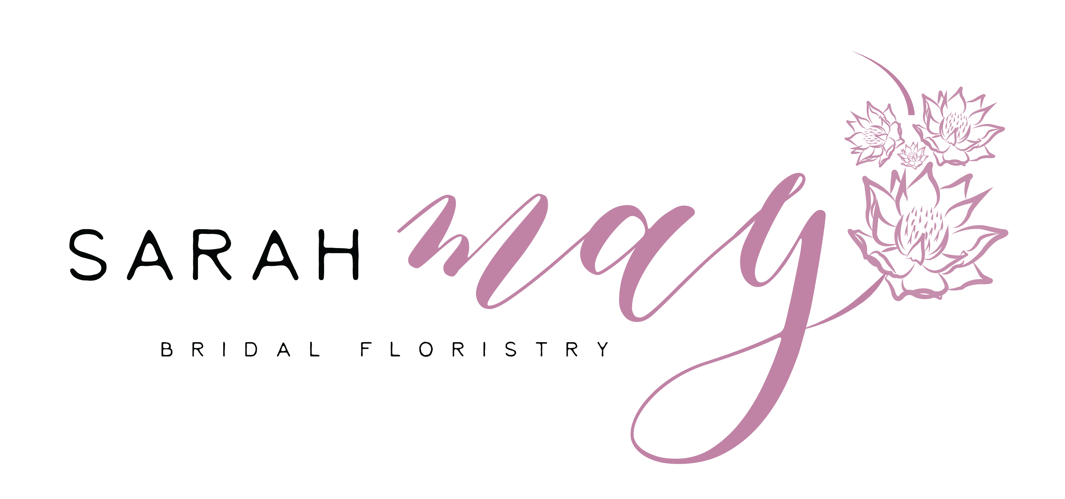

Thanks so much for contacting us for a Quotation as you can probably tell we love weddings and would love to be apart of yours!

Please fill in as much information as you can, you are also welcome to email me pictures so I can see your inspiration for your wedding. When you email the form back to me at

sarah@sarahmayfloralart.com

Please note: I have my own style of doing flowers, I am sure that is why you are contacting me for a quote, so I tend to put my own “spin” on florals. Also I prefer not to copy exactly what was done previously if possible but rather be inspired by what you show me and then create a new design especially for you!

TERMS AND CONDITIONS

- If I am hired as your florist, there is no floral work to be done by anyone else – ie. venue, family members etc, as this is a reflection on my business, in certain cases this can be discussed. There are to be no fake flowers mixed with my florals either.
- Availability of flowers quoted on – if they are unavailable another selection will be made
- Quotes based on pictures provided but please note a lot of these “pinterest photos” are unrealistic, so the best replacement will be used, pictures supplied will be used at inspiration.
- Excludes, candles/hiring of vases unless specified as my own. Lights etc – anything none floral
- If items are removed from quote, your quote will need to be amended.
- Succulents and orchids are hiring fees only.
- Florist booking fee (deposit) is 50% of the proposal value is non refundable and is payable on booking and confirming me for your event, this will be deducted from your final invoice. The balance is due two weeks before your wedding/event.
- Cancellations - the 50% florist booking fee/deposit is non refundable. If the event is cancelled this amount will cover any admin fees, other incurred expenses and will cover loss of business for the day. Any cancellation 1 month before the wedding/event will result in forfeiture of all monies paid over.
- Dropping of bouquets is a courtesy service on the day if the venue is close to where you are getting ready, all bridal party flowers are dropped together - bouttonieres bouquets etc If your venue is far then another arrangement will have to be made. As time is always a factor when setting up. Setup of churches is excluded unless specified.
- Setup can start as early as the Thursday or Friday before if allowed by venue. On day setup finishes at approx. 1pm.
- Forces of nature are out of our control, and we will do our best to accommodate any paid for items. We are able to also made alternate arrangements within reason to provide what was paid for if a certain setup isn’t possible.
- Hiring of items, wooden boxes and glassware if they are mine are included in my pricing. If anything goes missing or is broken, you are liable for the replacement value for that item. If a collection fee is not stipulated on your Invoice then you are liable to return those items hired.
- For any onsite work, such as arches/installations a styling fee will be applicable as we will have to be at your venue.
- Please return all delivery vases and crates that were used for the bouquets asap, I need them for delivery every weekend. If they are not returned they will be charged for.
- We do not do mock ups, only on special request and charged accordingly.
- PAYING OVER THE BOOKING FEE IS AN ACCEPTANCE OF THIS CONTRACT AS BEING YOUR FLORIST AND IS AN ACKNOWLEDGEMENT OF ACCEPANCE OF ALL THESE TERMS AND CONDITIONS AS STIPULATED.

Please sign: ____________________________

Date of your wedding:

Bride and Groom:

Estimation of floral budget:

- Do you view flowers and décor as an important part of your day?

- Where is the ceremony and what time?

- Where is the reception and what time?

- How many people are attending your wedding?

- Where is the bride getting ready? Where is the groom getting ready?

- Who is your photographer?

- Wedding Colour Scheme/Your inspo?

- Flowers and greenery you want/like/main colours wanting to use:

- Colour of your dress and bridesmaids dress?

- Bridal bouquet, size, any specific flowers?

- Bride maids bouquets, size, and how many?

- Flower crown, bridal or flower girl?

- Bouttonieres, how many for groom/groomsmen/dads?

- Corsages for moms/grannys? Pin or or wrist?

- Ceremony Flowers?

- Ceremonial Pergola/Arch (do you want to recycle to it your bridal table??)

- Wreaths in various sizes, suspended?
- Confetti -petals/eucalyptus leaves?

- Table arrangements ideas – do you want to have laid greenery, use glassware/wooden boxes/ceramic pots/other vessels?

- Suspended arrangements?
- Extra arrangements (cake/signing table)?

- Flowers for cake?

- Estimate of how many guest tables- seating how many per table and main table- seating how many. Or just a sweetheart (bridal couple)?

- Do you want your guests and main table to differ? How so?

- Are you aware of our floral napkins for hire? You qualify for a special hiring discount if you book us for both.

- Do you want me to hang any other items/make sure anything else is done on the day?

- Anything else you would like to add?

